SQL QUERIES

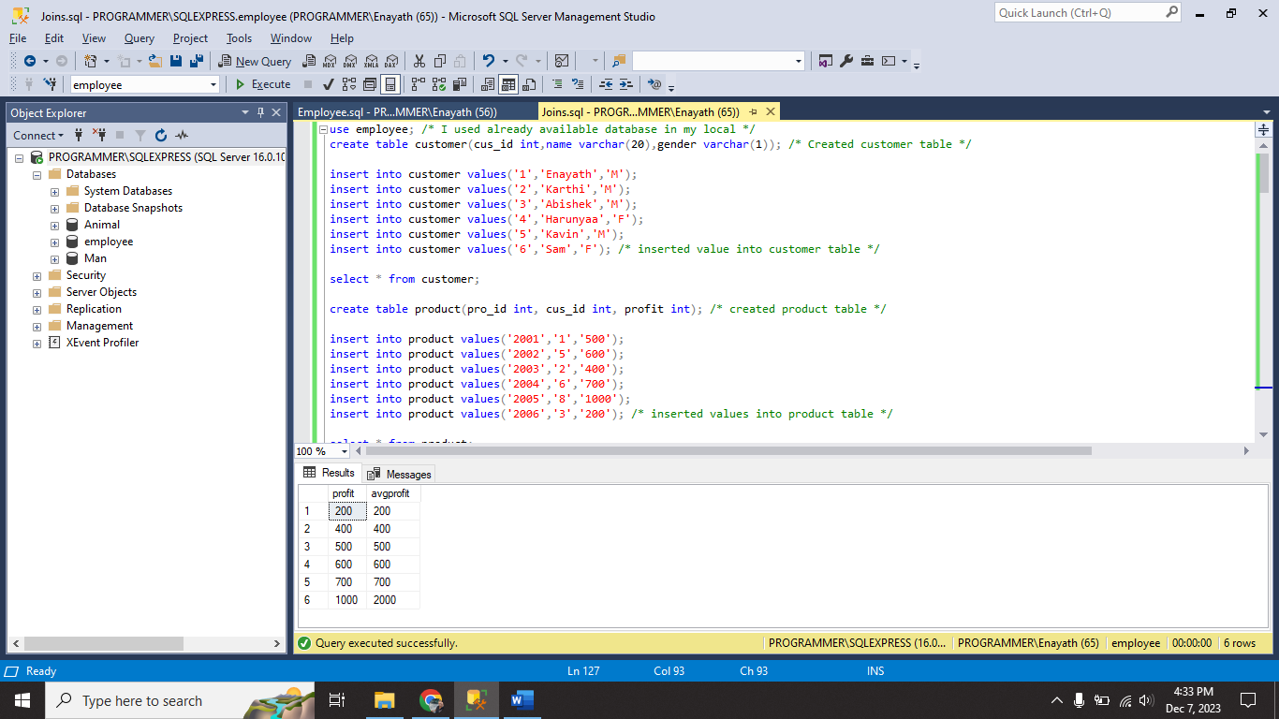

I created two tables customer and product

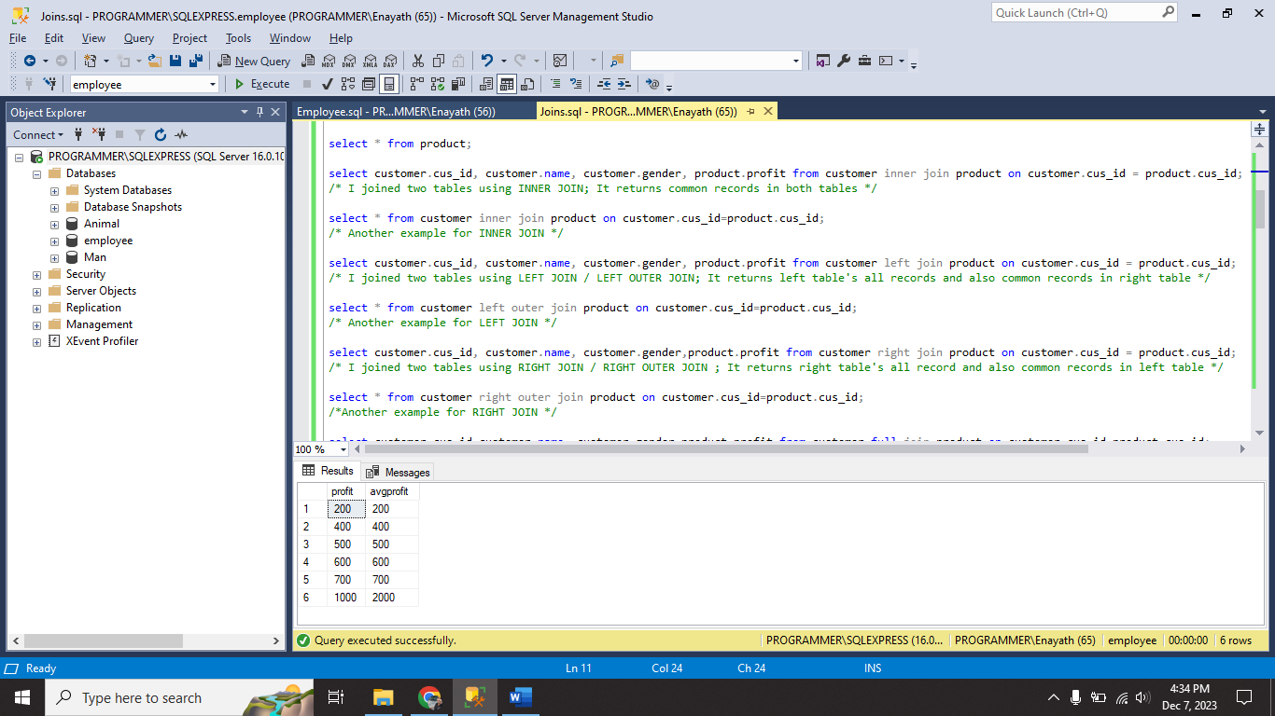

I used all the joins (**INNER JOIN, LEFT JOIN/LEFT OUTER JOIN, RIGHT JOIN/RIGHT OUTER JOIN , CROSS JOIN** and **FULL JOIN/FULL OUTER JOIN**) and its all successfully executed.

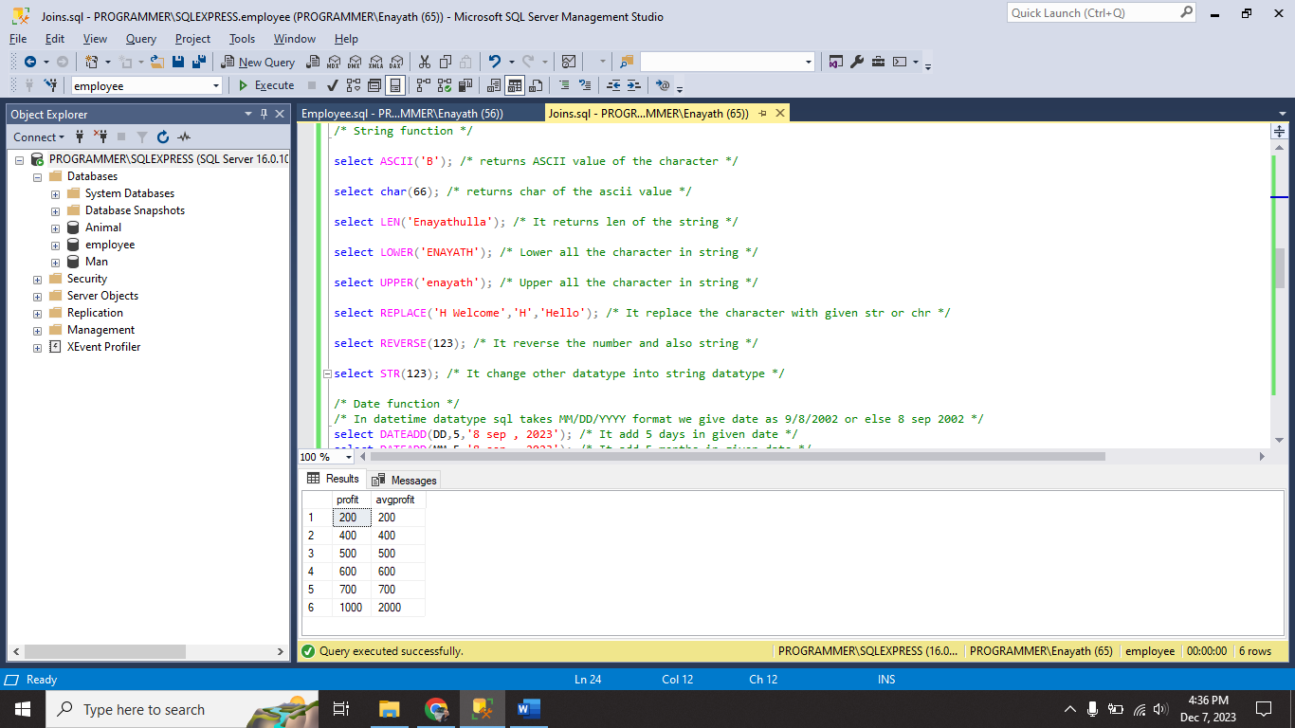

I used some string functions (**ASCII, CHAR,LEN, LOWER, UPPER, REPLACE, REVERSE** and **STR**) and its successfully executed.

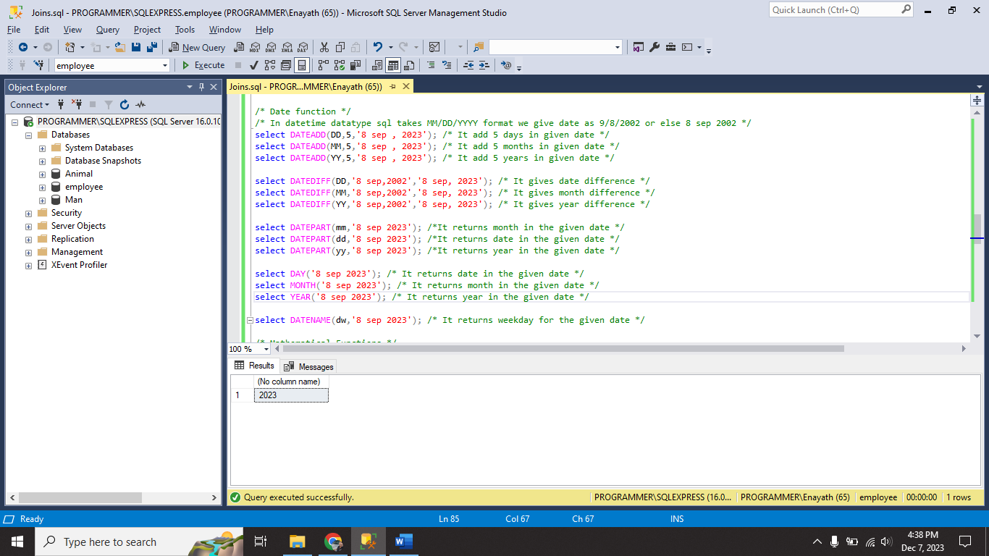

I used some datetime functions (**DATEADD, DATEDIFF, DATEPART, DATENAME, DAY, MONTH** and **YEAR**)

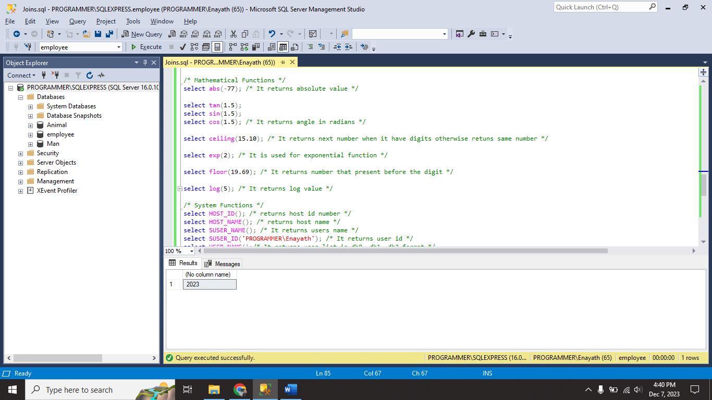

I used some maths functions(**ABS, SIN, COS, TAN, CEILING, EXP, FLOOR** and **LOG**)

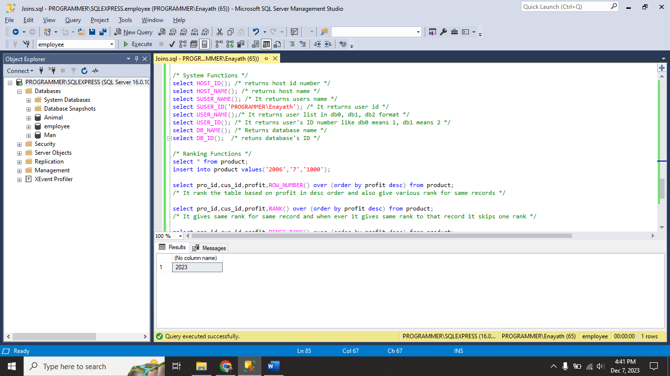

I used some system functions (**HOST_ID, HOST_NAME, SUSER_ID,SUSER_NAME, USER_NAME, USER_ID, DB_NAME** and **DB_ID**)

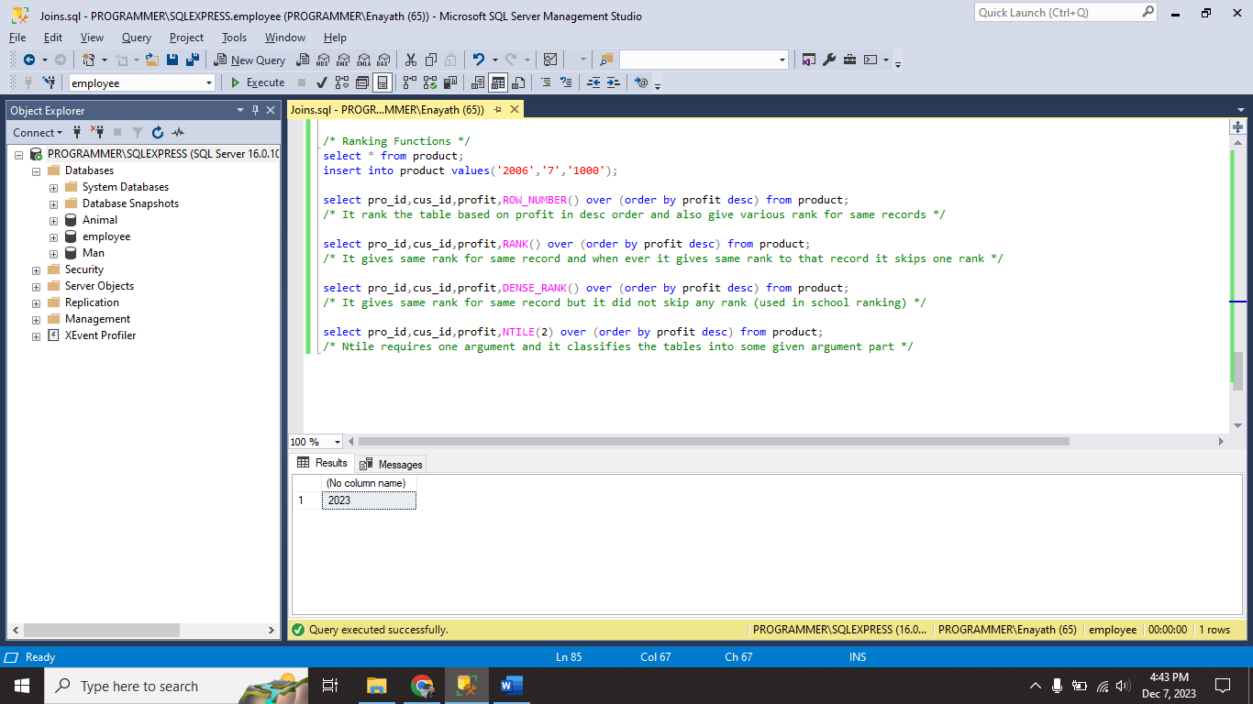

I used some ranking functions (**ROW_NUMBER, RANK, DENSE_RANK** and **NTILE**).